Ideation Phase
Define the Problem Statements

Date | 31 January 2025
Team ID
Project Name | E-Commerce
Maximum Marks | 2 Marks

Customer Problem Statement Template:
To define the core problems that small business owners and online sellers face and use these insights to build a better e-commerce solution.
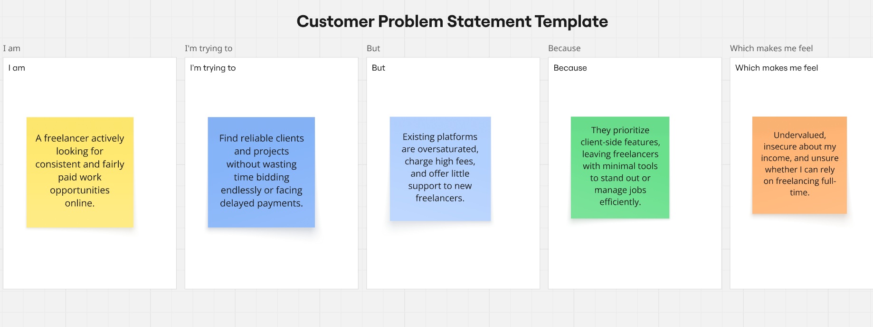
Reference: https://miro.com/templates/customer-problem-statement-ecommerce/

Problem Statement (PS) | I am (Customer) | I’m trying to | But | Because | Which makes me feel
PS-1 | Small business owner selling products online | Create a smooth online shopping experience for my customers. | My current website is slow, outdated and hard to manage. | I don’t have a proper technical knowledge | frustrated and losing customers.
PS-2 | E-commerce startup founder | Increase my sales through an attractive and user-friendly online store. | Most platforms are confusing, expensive. | I can’t customize features the way my business needs. | Stuck and limited.

